EXPERIMENT 2
2. Create a simple cloud software application for Property Buying & Rental process (In Chennai city) using any Cloud Service Provider to demonstrate SaaS include the necessary fields such as Buy, Rent, commercial, Rental Agreement , Rental Agreement, Area, place, Range, property value etc.
AIM
To create a Property Buying & Rental System for Chennai city using Zoho One as a cloud-based Software as a Service (SaaS) application.
Procedure
- Log in to the Zoho One cloud platform.
- Open Zoho Creator from the Zoho One applications.
- Create a new application for the Property Buying & Rental System.
- Create a new form named Property Buying & Rental.
- Add the required fields:
  - Customer Name
  - Property Type (Residential / Commercial)
  - Transaction Type (Buy / Rent)
  - Area
  - Place (Chennai locations)
  - Budget Range
  - Property Value
  - Property Size (Square Feet)
  - Rental Agreement (Yes / No)
  - Contact Number
- Configure the field types according to the data required.
- Add Chennai locations such as T. Nagar, Anna Nagar, Velachery, Tambaram, and Adyar to the Place dropdown field.
- Design and arrange the form for easy user interaction.
- Save and publish the form.
- Enter sample property buying or rental details into the form.
- Submit the form and verify that the entered data is stored in the cloud.
- Test the application by entering different property details for buying, renting, residential, and commercial properties in Chennai.
- Verify that the Property Buying & Rental System works successfully as a SaaS application.

INPUT

OUTPUT
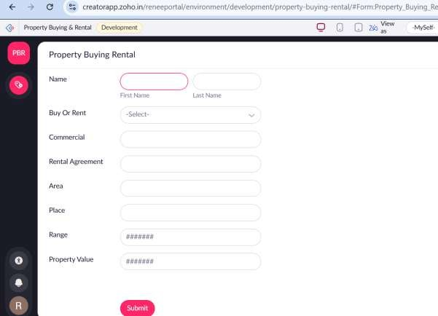
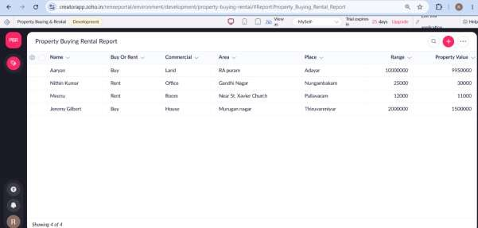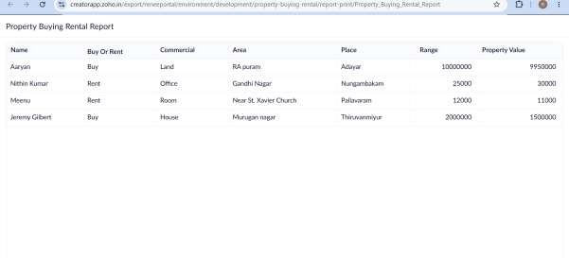

Result
Thus, a Property Buying & Rental System for Chennai city was successfully created using Zoho One and demonstrated as a Software as a Service (SaaS) application

